|  |  |  |  |  |
| --- | --- | --- | --- | --- |
| Metrics | Custom CNN | MobileNet | VGG16 | Wav2Vec2.0 |
| Precision | 0.48 | 0.74 | 0.62 | 0.93 |
| Recall | 0.50 | 0.69 | 0.58 | 0.93 |
| F1-Score | 0.34 | 0.68 | 0.55 | 0.90 |
| Accuracy | 0.5 | 0.69 | 0.58 | 0.93 |

Custom CNN

Pre-Trained Model

ASVspoof 2021 DF Testing

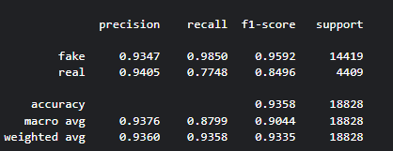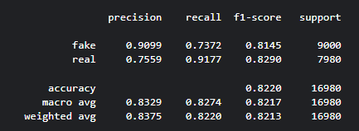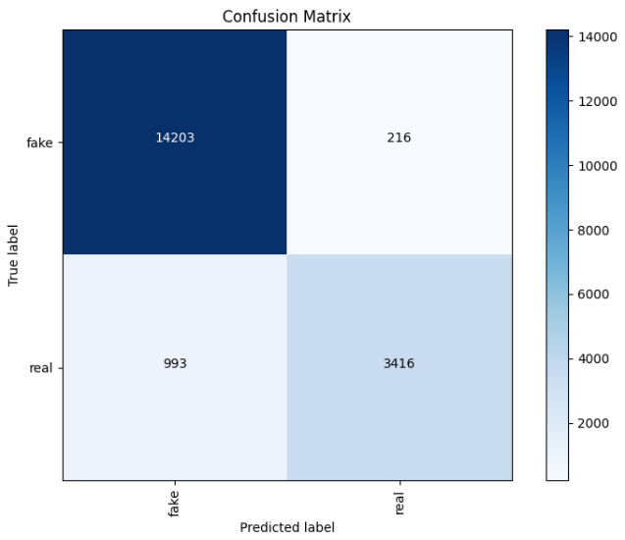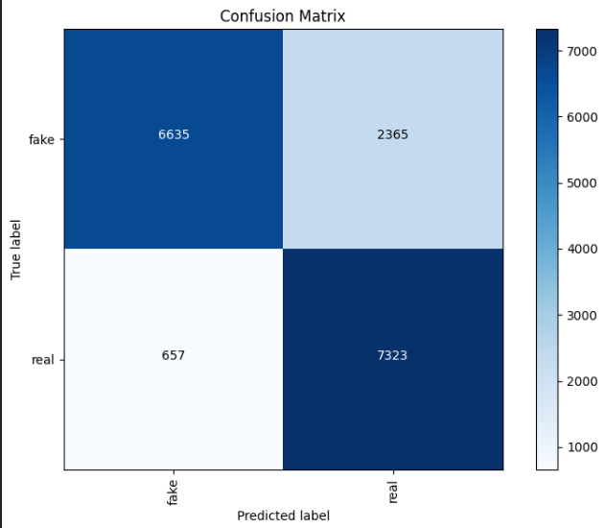

ASVspoof 2019 Testing